Code No.: |  | HTU/P9 |  | Date Established | 9/11/2017
Responsible  Department |  | Deanship of the programme |  | Date Posted | 9/11/2017
Responsible Executive |  | Vice President or President of HTU |  | Date Last Revised  Revision # 2 | 08/11/2023
Quality Nominee |  | Rumiana Bahova Nuseibeh |  | Forward Revision Date | 08/11/2024

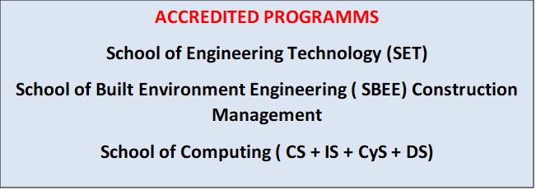

Complaints Policy

This Document was last revised : 8th November 2023

HTU is committed to delivering high quality services and products which meet the needs of our customers and regulatory requirements. We put customer service and quality at the heart of what we do and strive to get it right, first time, every time. However sometimes things don't go as planned and in order to help us to improve the quality of our work we value the your feedback.
- What to do if you have a query, a concern or a complaint
Most queries or concerns can be resolved quickly by contacting our subject specialist and administrative staff. They will do their best to resolve the matter quickly to your satisfaction. If you have a formal complaint, however, please send your complaint by emailing the Dean ( Programme Leader ) of the respected faculty of the Deanship and Student Affairs with providing details as to the nature of the complaint.

Submitting a formal complaint
When a complaint is submitted formally, the following details should be provided:
- Your full name and contact details (including a daytime telephone number and email address)
- A full description of the complaint (including the subject matter and relevant dates and times if known)
- The names of the people at HTU who have been involved in the matter so far, if known
- Copies of any relevant documents and reference to any earlier correspondence.
- What happens next

4.1 Stage 1 investigation
HTU will acknowledge your complaint within 5 working days of receipt. Once a formal complaint is received, it will be referred to a lead officer to investigate and respond.
The (Dean) Programme Leader will respond to your complaint normally within 10 working days of receipt. If a complaint is more complex or involves staff who are unavailable it may take longer to investigate. In such circumstances, the lead officer will advise you of the timescale for responding. We may also contact you within this period to seek further information or clarification.
4.2 What if I'm not satisfied with the outcome – Stage 2 investigation
If you are not satisfied with the outcome of the stage 1 investigation, you are able to submit an appeal in writing to the Dean ( Programme Leader) of the respected faculty. The appeal must clearly set out the grounds of the appeal. Your appeal will be acknowledged within 5 working days of receipt. A lead manager with no previous involvement in the complaint or conflict of interest will lead the appeal investigation.
We aim to complete the stage 2 investigation within 10 days and will communicate the outcome to you. If a complaint is more complex or involves staff who are unavailable it may take longer to investigate. In such circumstances, the lead manager will advise you of the timescale for responding. We may also contact you within this period to seek further information or clarification.
Once the stage 2 investigation has been completed, there are no further internal stages.
The scope of this complaints procedure does not include a number of procedures for which there are alternative arrangements, namely, Post Results Services and appeals against enquiries about results, malpractice, special consideration, access arrangements or other examination administrative arrangements such as very late arrivals, missing scripts or others. Please refer to HTU policies and procedures for further detailed processes.

End of Policy.

